**“Experiment 2.1”**

Student Name: **SUMIT KUMAR** UID: **20BCS8226**

Branch: **CSE** Section/Group: **808 A**

Semester: **5** Date of Submission: **27-09-22**

Subject Name: **Multimedia Technologies Lab**  Subject Code: **20CSP-339**

**1. Aim/Overview of the practical:**

**You are given a picture of a garden as background. Extract the image of a butterfly from another picture and organize it on the background using photopea.**

**2. Which logistics used:**

Hardware Requirements: - Minimum 384MB RAM, 100 GB hard Disk, processor with 2.1 MHz

Software Requirements: - Photopea

Tools Used: - Magic Cut, Lasso select.

**3. Steps for experiment/practical/Code:**

**Step 1:** Create new project on Photopea, and specify dimensions as required.

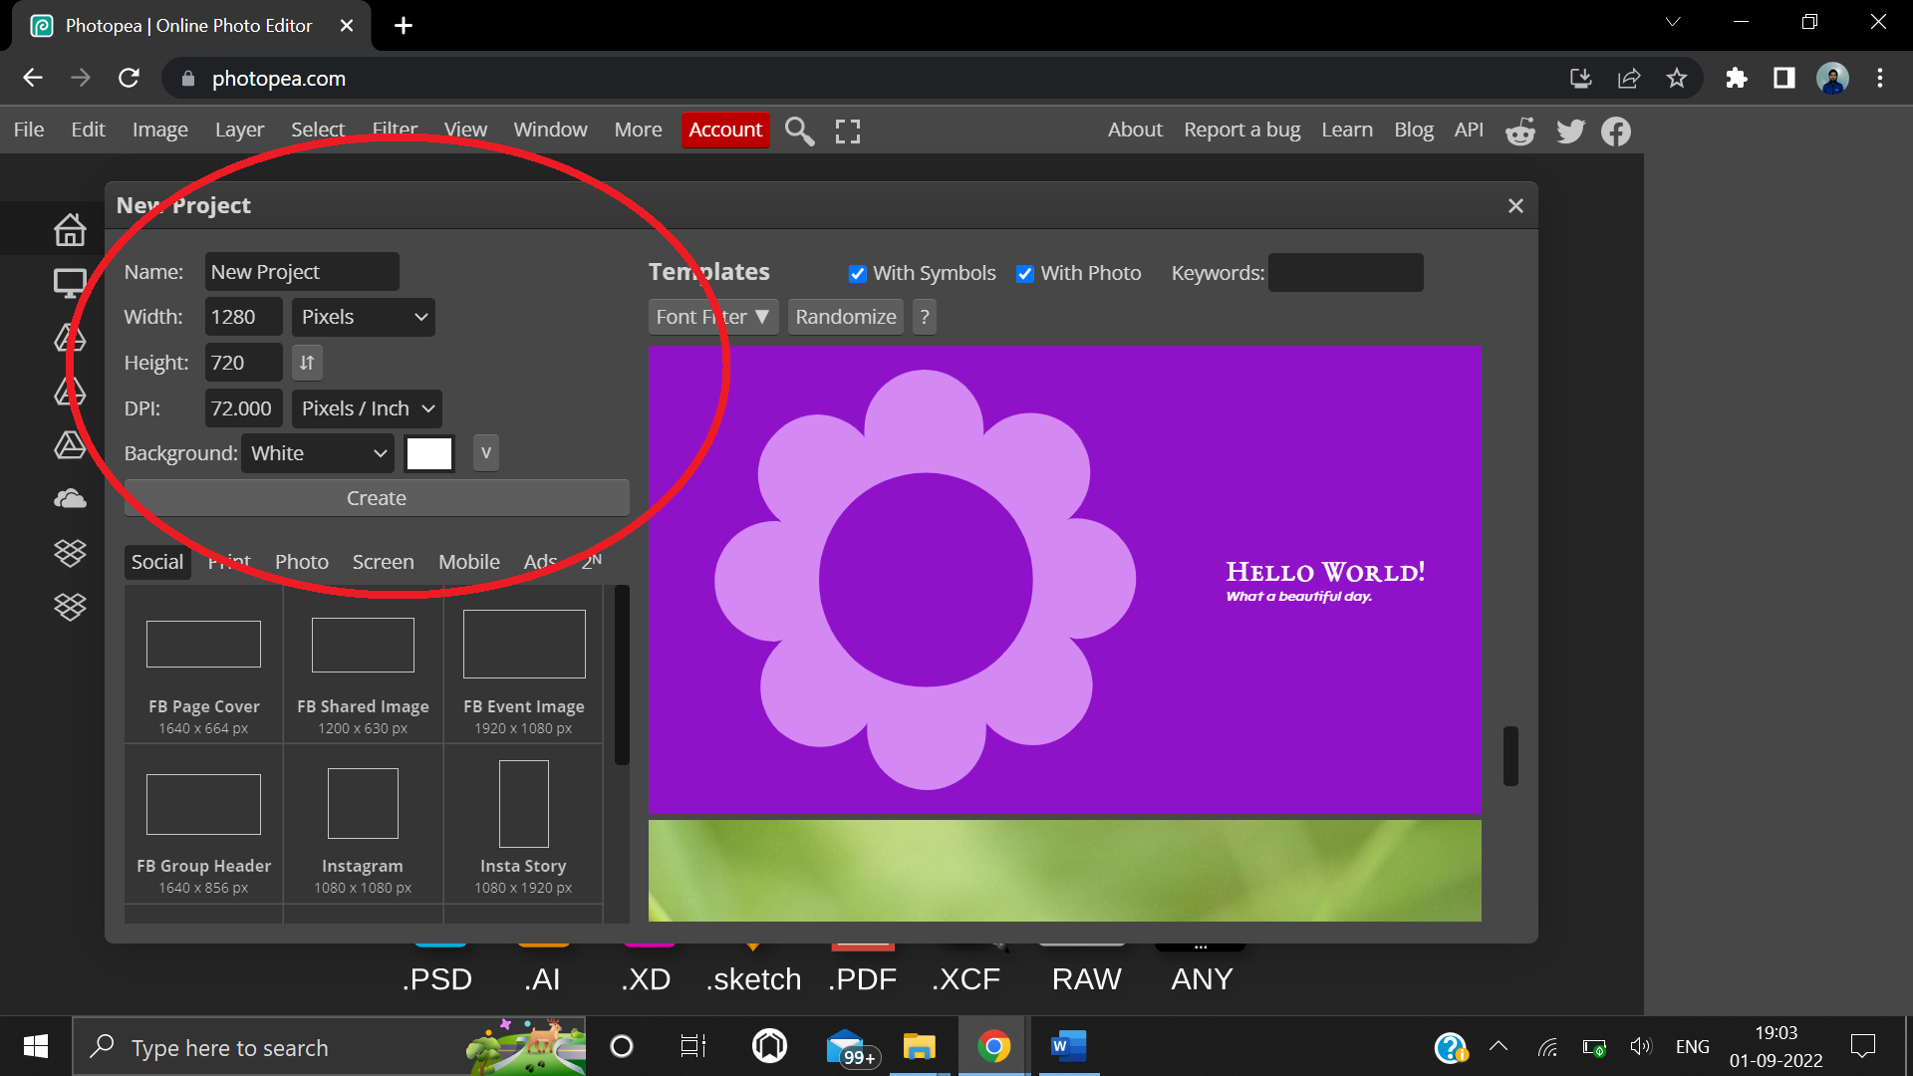

**Step 2:** Copy a garden image from google and paste on the screen for background.

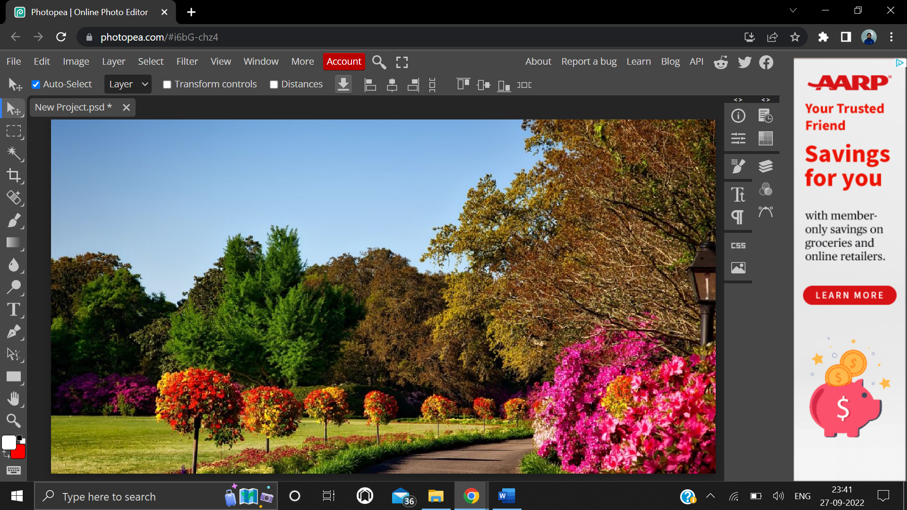

**Step 3:** Copy a butterfly image from google and paste on the screen.

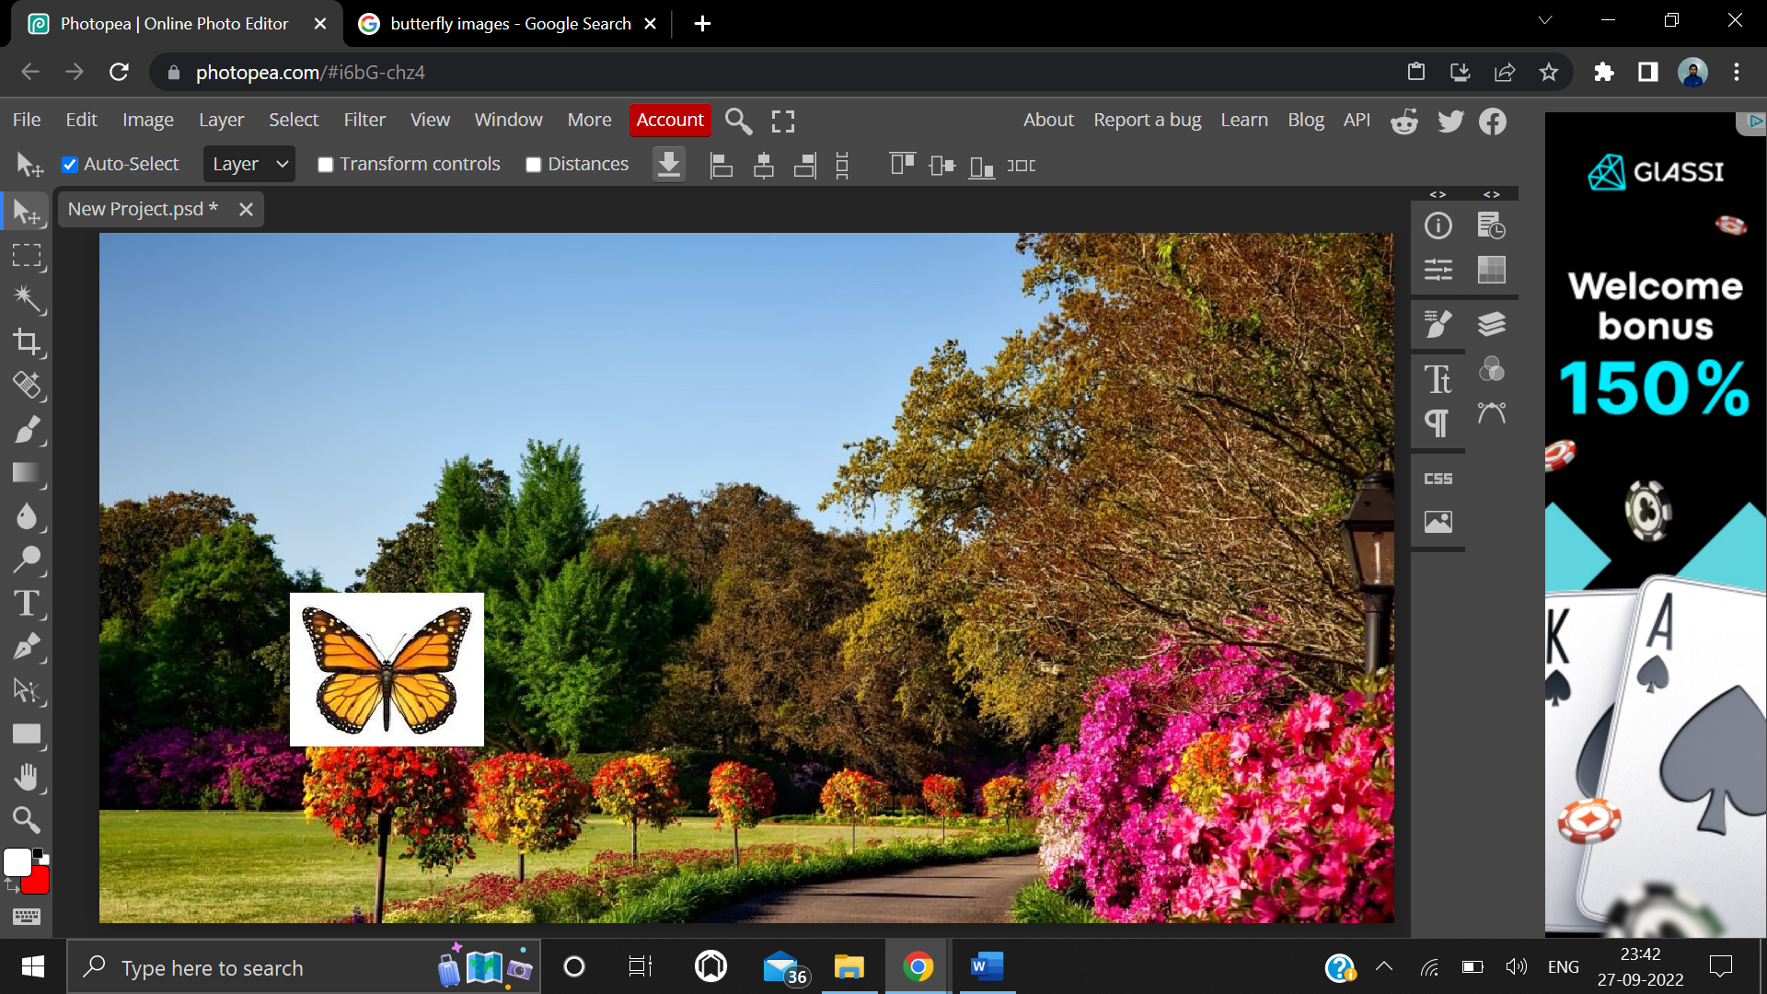

**Step 4:** From the top navbar, click Select, and select Magic Cut from the dropdown menu to remove the background from the photo.

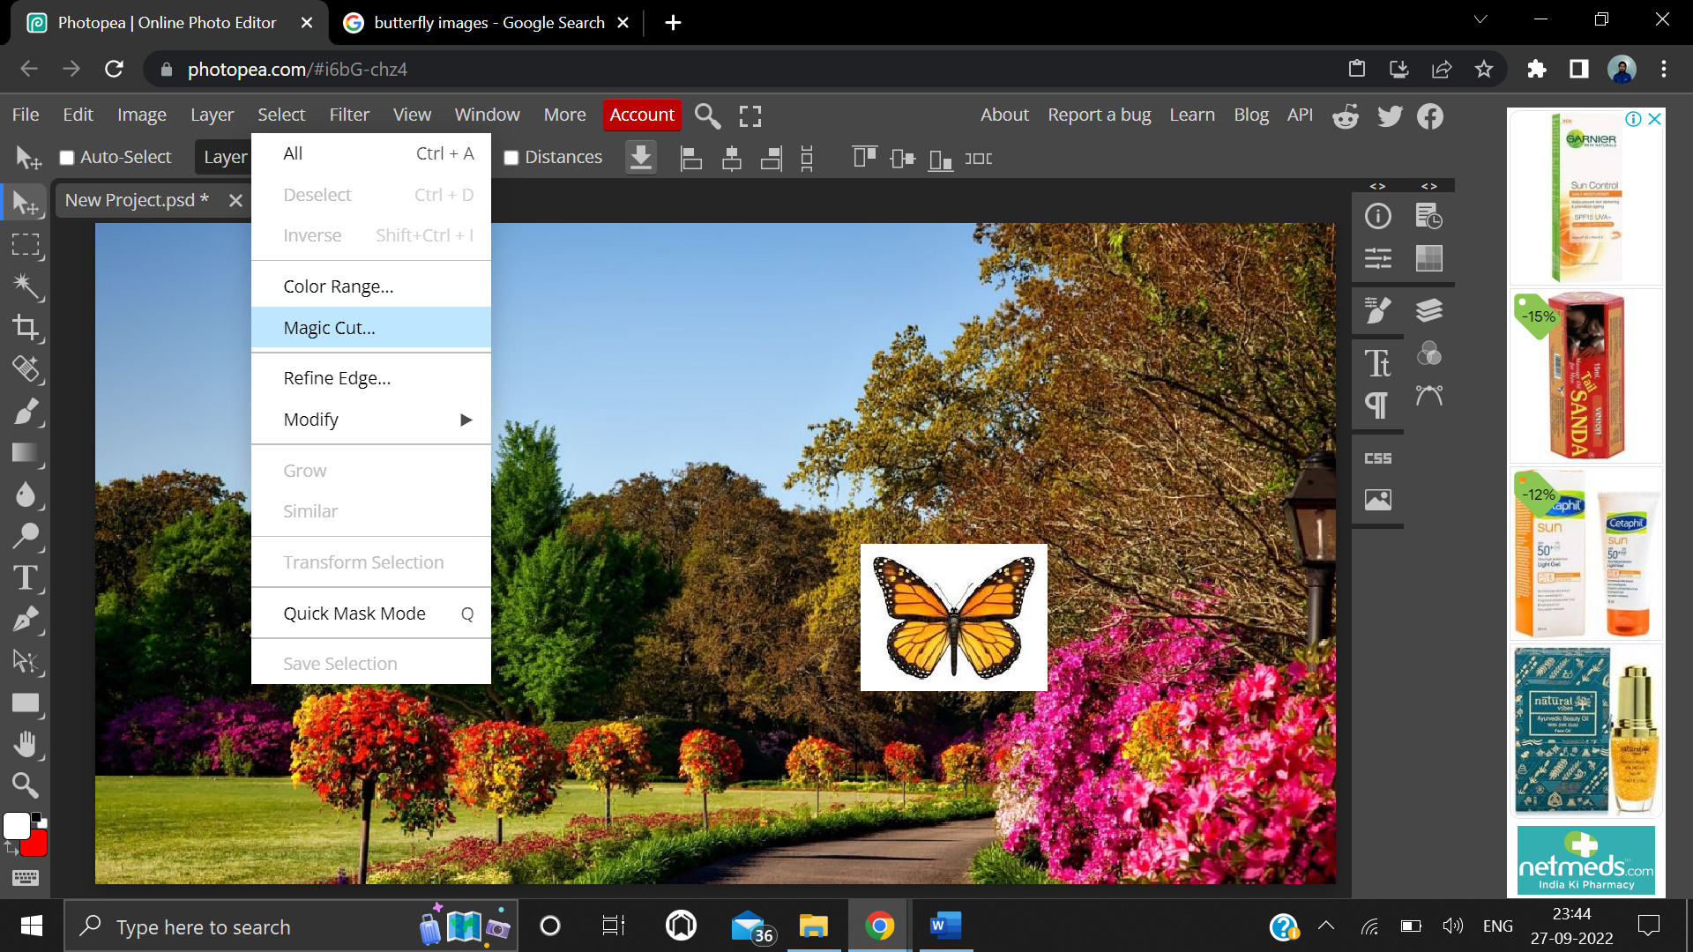

**Step 5:** Click on “OK”.

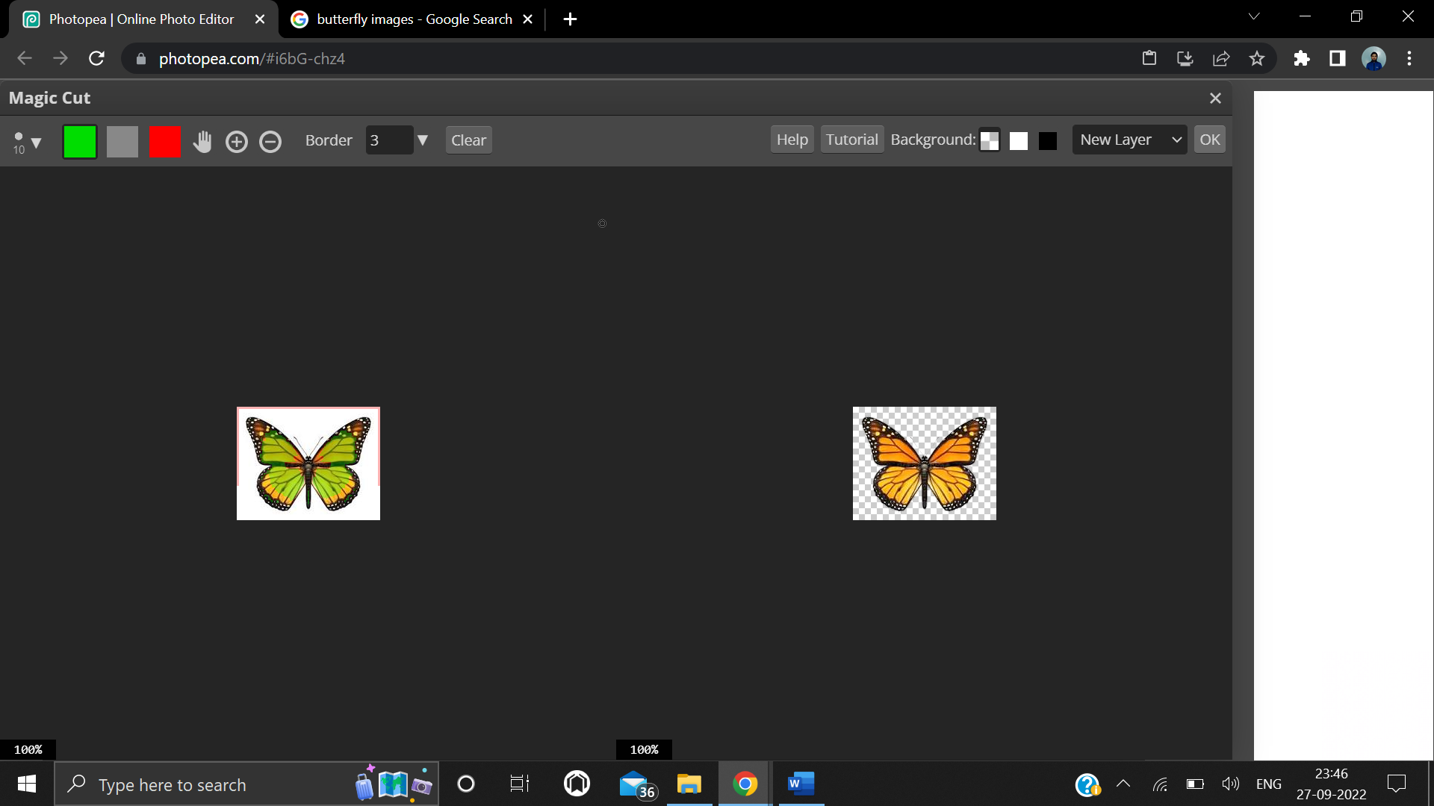

**Step 6:** Finally, organize the butterfly and place it on screen where you want.

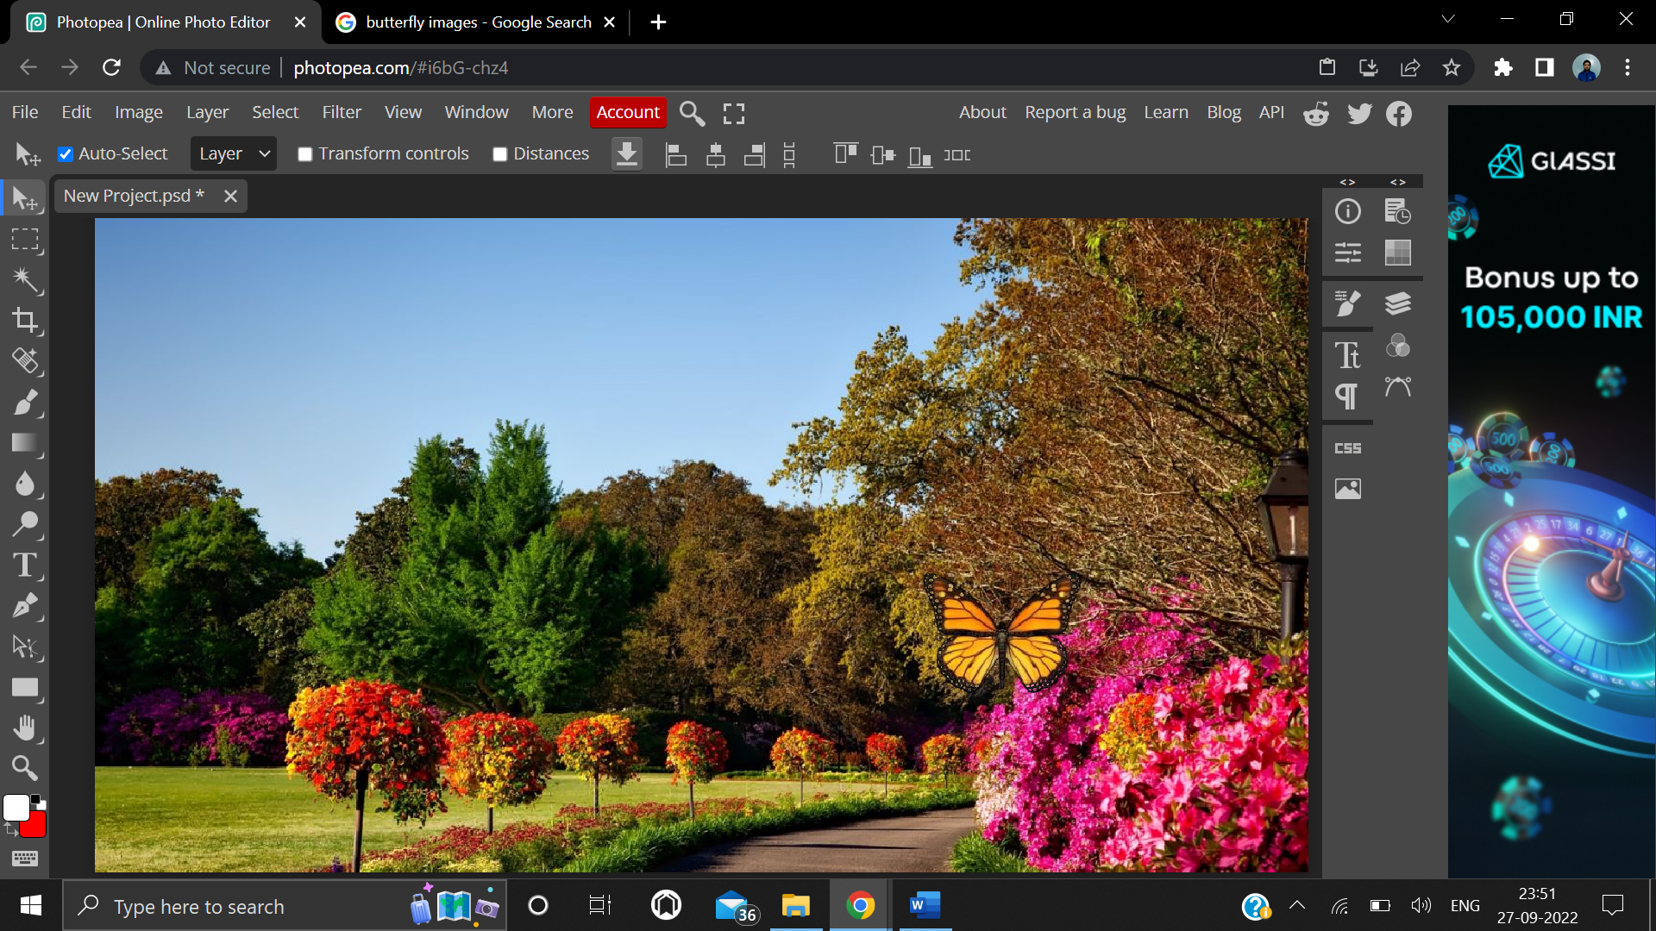

**4. Result/Output/Writing Summary:**

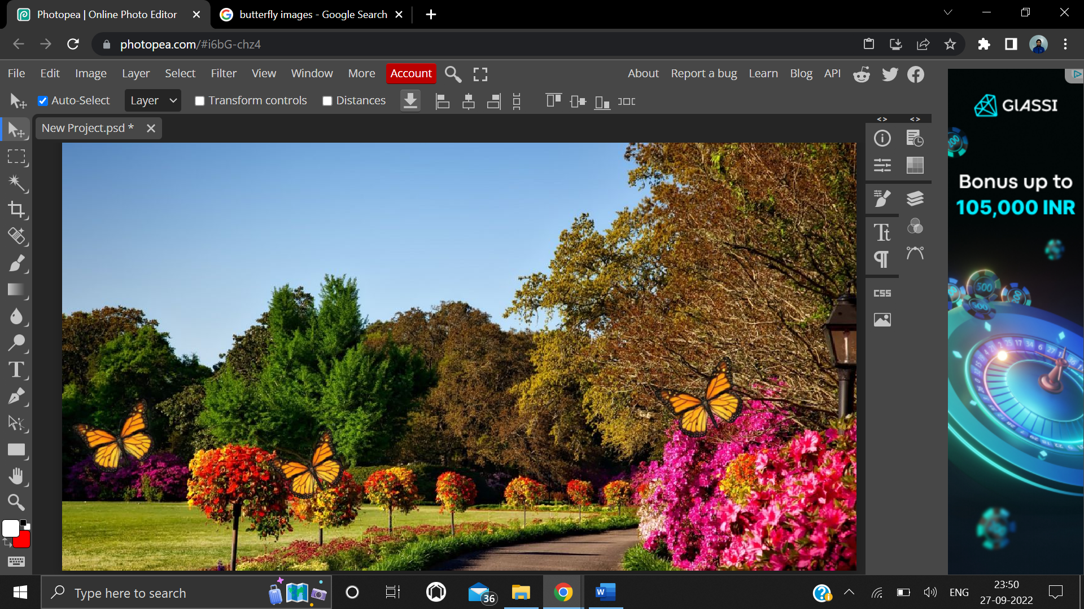

**Butterfly organized on garden background**

**Learning outcomes (What I have learnt):**

**1.** Learnt how to remove background from a photo using Magic Cut tool on Photopea.

**2.** Learnt about many different effects that can be added to images for different purposes.

**3.** Learnt how to change the background of any image on Photopea.

**4.** Learnt how to make combination of two different images.

**Evaluation Grid (To be created as per the SOP and Assessment guidelines by the faculty):**

|  |  |  |  |
| --- | --- | --- | --- |
| Sr. No. | Parameters | Marks Obtained | Maximum Marks |
| 1. |  |  |  |
| 2. |  |  |  |
| 3. |  |  |  |
|  |  |  |  |